

Introduction

Game Summary Pitch
"The_Project" offers a stripped-down but immersive stealth survival experience, emphasizing intelligence, tension, and adaptability over brute force. Escape is not guaranteed—only earned by mastering shadows, silence, and the unseen forces manipulating everything from behind the scenes.

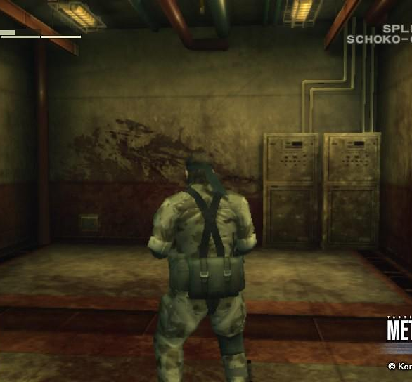
Inspiration
Metal Gear Solid
The standard for single-player stealth action games. Cameras, Patrolling guards, environmental distractions will all be integral in making The Project work as intended.

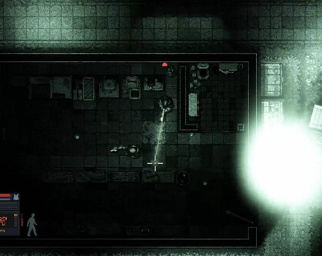
Intravenous
While Intravenous is a stealth action game with a heavy emphasis on “action”, The art style is a definite inspiration. CRT overlaid on a 16 bit topdown stealth game.

Player Experience
The player assumes the role of a mysterious test subject who awakens in a partially collapsed experimental facility. The player will utilize mental “hacking” abilities and the environment to evade increasingly complex security systems and patrolling guards and/or failed test subjects to reach their goal. The player slowly uncovers their own “experimental” abilities, hacking cameras and lights through mental abilities. The more they’re used, the stronger they get.

Platform
The game is developed to be released on windows PC

Development Software
- Godot for programming
- Aseprite for graphics and UI
- FL Studio 12 for all music and SFX

Genre
Singleplayer, stealth, survival

Target Audience
Without heavy or complicated ideas, and intuitive-to-grasp mechanics, this game is marketed to at least stealth, survival game players who are up for puzzling challenges as well as more veteran players up for solving complicated problems. Horror and mystery fans.

Concept

Gameplay overview
The player assumes the role of a mysterious test subject who awakens in a partially collapsed experimental facility. Using stealth, environment manipulation, and intelligence, they must evade increasingly sophisticated security systems to uncover the truth behind "The Project" and escape the facility.

Theme Interpretation (Survival in its rawest form)

WIP

Primary Mechanics

Mechanic | Animated Mockup  (Art not necessarily final)
Phase Shift | Briefly phase through thin walls
Silent Step | Temporarily eliminate all footstep sounds
Vision Cloak | Partial invisibility when stationary in shadowed areas
Remote Hack | Disable/distract electronics from a distance

Secondary Mechanics

Mechanic | Animated Mockup  (Art not necessarily final)

Art



Theme Interpretation
Minimalist, dark, sterile aesthetic
Horror-inspired

Cold color palette (blues, grays, muted whites)

High-contrast shadows and light sources

Design
A very minimalistic approach will go into the design of the game, heavily relying on the shadows and cold colors. You are an experiment in a sterile facility. Some sectors have seen hell, and the world will show that. Retro style, CRT overlay.

Audio

Music
Fear, uncertainty, determination should be inspired by the music. Heavy use of reverb and effects to fill space within the few instruments. Synths to be used sparingly, horror inspired sound effects should maintain priority. The player should be uneasy. This is not a clean escape, there will be blood. Probably their own.

Sound Effects
Brutalistic sounds. Heavy footsteps on concrete, metal. Shattered glass crumples beneath the player’s feet. Ominous reverb and industrial sounds at the forefront. Piercing alarms that increase your heart rate because you know your lifespan has been shortened.

Game Experience

UI
On top of the rigid pixel art constituting the rest of the art, a more smooth, higher definition style will be incorporated in the UI. Utilizing many shades of white and black allowed in the art restriction, anti-aliasing is used to further emphasize the UI.

Controls
Keyboard
Arrow keys / WASD, R - Restart
Gamepad
Dpad

Development Timeline

MINIMUM VIABLE PRODUCT (MVP)

# | Assignment | Type | Status | Finish By | Notes
1 | Design Document | Other | Finished | Jun 22, 2022
2 | Create player and wall assets | Art | Not started | Jun 23, 2022 | Prototype for GDD is done
3 | Main menu theme | Audio | Not started | Jun 23, 2022 | Can be really short, player won’t be on main menu for long
4 | UI / Main menu | Coding | Not started | Jun 23, 2022 | Button UI, screen transition, title screen
5 | Level theme | Audio | Not started | Jun 24, 2022 | Should be more substantial and not annoying
6 | Simple player movement | Coding | Not started | Jun 23, 2022 | 8 Directional Movement
7 | Enemy AI | Coding | Not started | Jun 23, 2022 | Pathing, Alertness, etc.
8 | Environmental Triggers | Coding | Not started | Jun 23, 2022 | Cameras, Lights, Alarms, etc.
9 | Cutscenes | Art | Not started | Jun 23, 2022 | Cryptic, ominous, progressing story
10 | Special effects | Art | Not started | Jun 25, 2022 | Ability effects, alert, etc.
11 | Player animation | Art | Not started | Jun 25, 2022 | movement polish
12 | Sound effects | Audio | Not started | Jun 25, 2022 | Player movement, UI interaction
13 | Pause / settings menus | Coding | Not started | Jun 26, 2022 | Access to the main menu or resetting the level
14 | Level select menu | Coding | Not started | Jun 26, 2022
15 | Level design (1-7) | Other | Not started | Jun 27, 2022 | Create levels 1 through 7
16 | Level design (8-15) | Other | Not started | Jun 28, 2022 | Create levels 7 through 15
17 | Any extra polish | Other | Not started | Jun 29, 2022
18 | SUBMIT | Other | Not started | Jun 29, 2022 | Create Itch Page and upload

BEYOND (if ahead of schedule / extra time)

Dynamic lighting system | Coding | Not started | Enhanced Stealth Gameplay
Advanced AI states | Other | Not started | Searching, coordinated patrols
Co-op multiplayer mode | Coding | Not started | synchronized stealth

Addendum — Opening Narrative & Level Progression (July 2026)
This addendum extends the design foundation above; nothing in the preceding sections is modified by it.

Opening Narrative Frame: The Waking-Up Sequence
The player character is a test subject at the facility. An unknown amount of time has passed since they were brought in. The game opens with them waking up at the bottom floor of the facility — a basement/dungeon level — with no memory of how much time has elapsed or what has been done to them. That uncertainty is a load-bearing part of the horror: the player should never be handed a clean answer to "how long was I under?"
Level_0 realizes this frame as the waking-up sequence. The level opens on a held cinematic beat (the red-eyes image that set the tone for the project), then fades into a dark basement cell with a bloodstained tile floor. A brief forced-still moment precedes control unlocking. The first obstacle is environmental, not hostile — a sealed door on the cell forces exploration outward rather than confrontation. The patrol drone is first encountered at a distance, glimpsed safely from the corridor, establishing the threat before it can ever punish the player. The sequence closes at a stairwell leading up into the facility: a forward hook, not a checkpoint screen.

Level Progression Concept: Bottom to Top
The player starts at the bottom of the facility and works upward over the course of the game. The environment gets cleaner as they ascend — the climb out of the earth is also a climb out of the facility’s buried history, and the art direction should sell that gradient level by level.
Basement / dungeon (Level_0): bloodied, decaying, oppressive. Failed experiments, old stains, rot. The waking-up sequence lives here.
Labs and blacksite-style rooms (mid-game): clinical, cold, sterile. The existing hospital and morgue tilesets are strong candidates for this tier — bright surgical whites and cyans that read wrong precisely because they are clean.
Offices (late-game): mundane and human. Desks, paperwork, coffee cups — the banal administrative layer that signed off on everything below it.
Front door (the end): the exit. Daylight as the final reward of the ascent.

